Academic Direction: University College London (UCL)
DON'S GLOBAL UNIVERSITY
Home
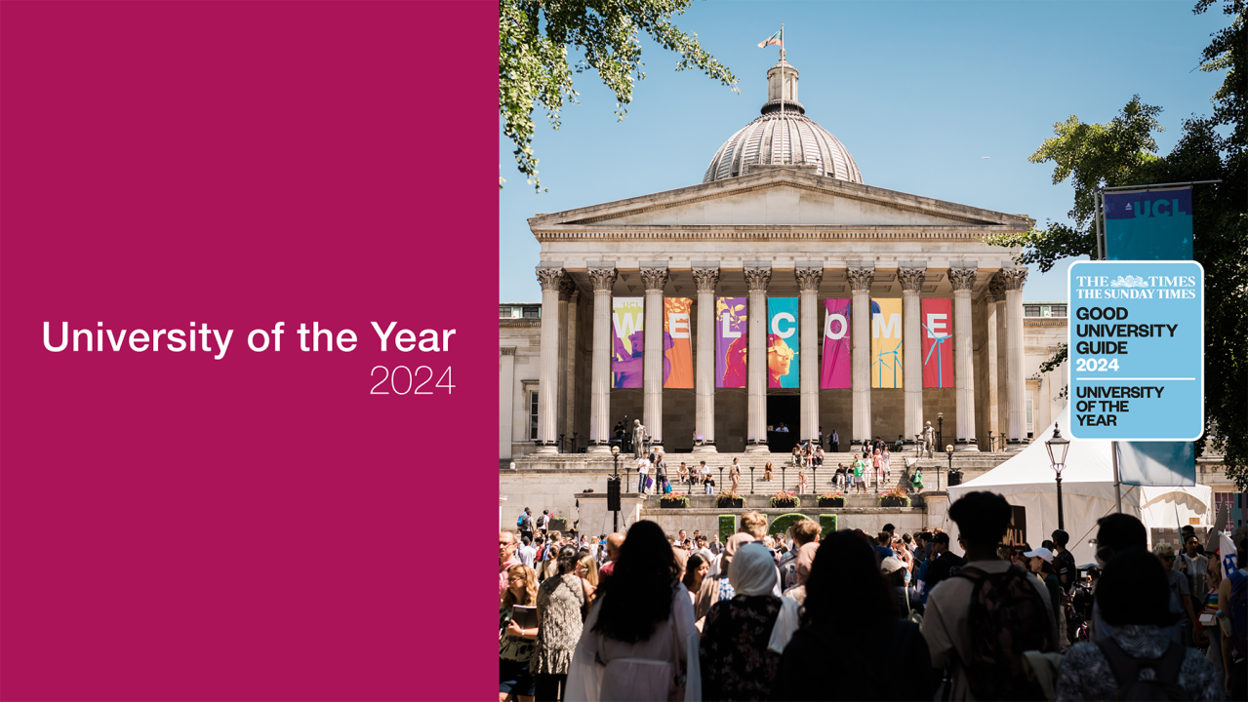

Gain knowledge. Gain advantage.

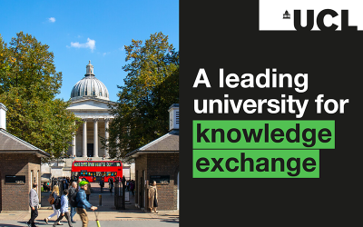

UCL retains its position as a leading institution in fourth Knowledge Exchange Framework

1st
UCL is University of the Year 2024 (The Times and Sunday Times Good University Guide 2024)
2nd
UCL was rated 2nd in the UK for research power in the Research Excellence Framework 2021
9th
UCL is ranked 9th in the 2025 QS World University Rankings
30
There have been 30 Nobel Prize laureates amongst UCL’s alumni and current and former staff to date

